Step one – make the virtual environment



Activate



Install flask



Pip freeze



Set the server



Run the server



TESTING:

Test getAll:



Test findByID:



Test create and show created run:

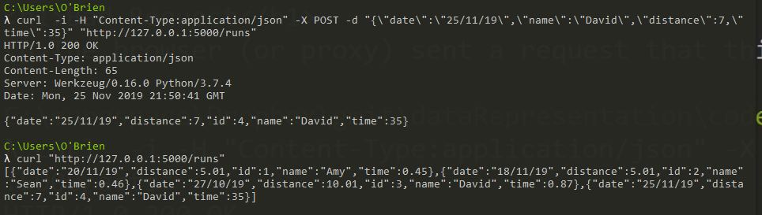

Test delete and show runs following delete:

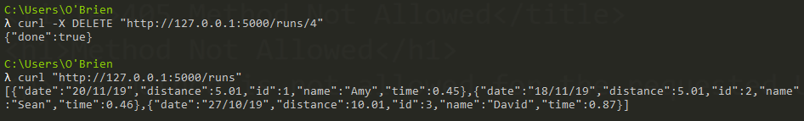

To exit virtual environment

